

Ans (i)::

130

G = ----------------

s^2 + 15 s + 130

## Continuous-time transfer function

# Peak Time (tp):

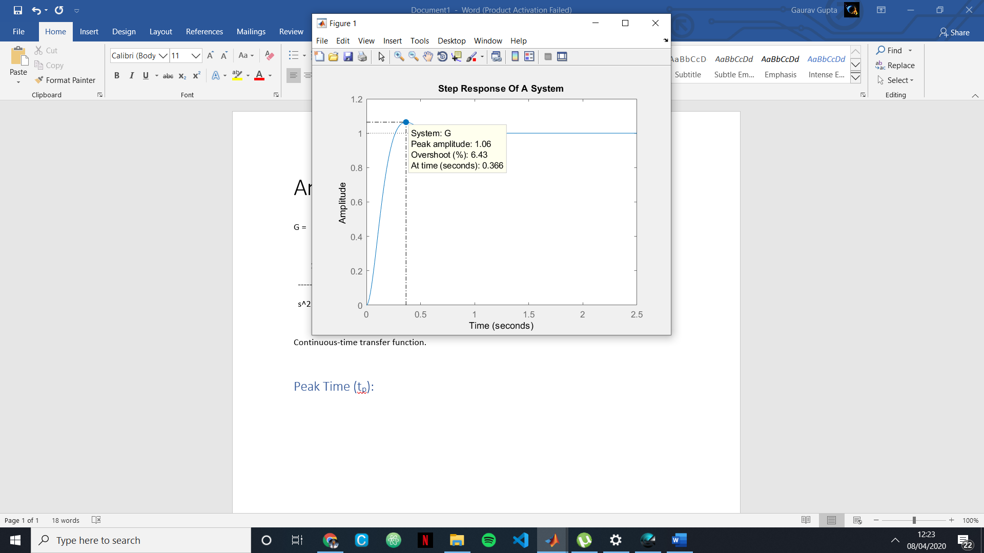

# Settling Time (ts):

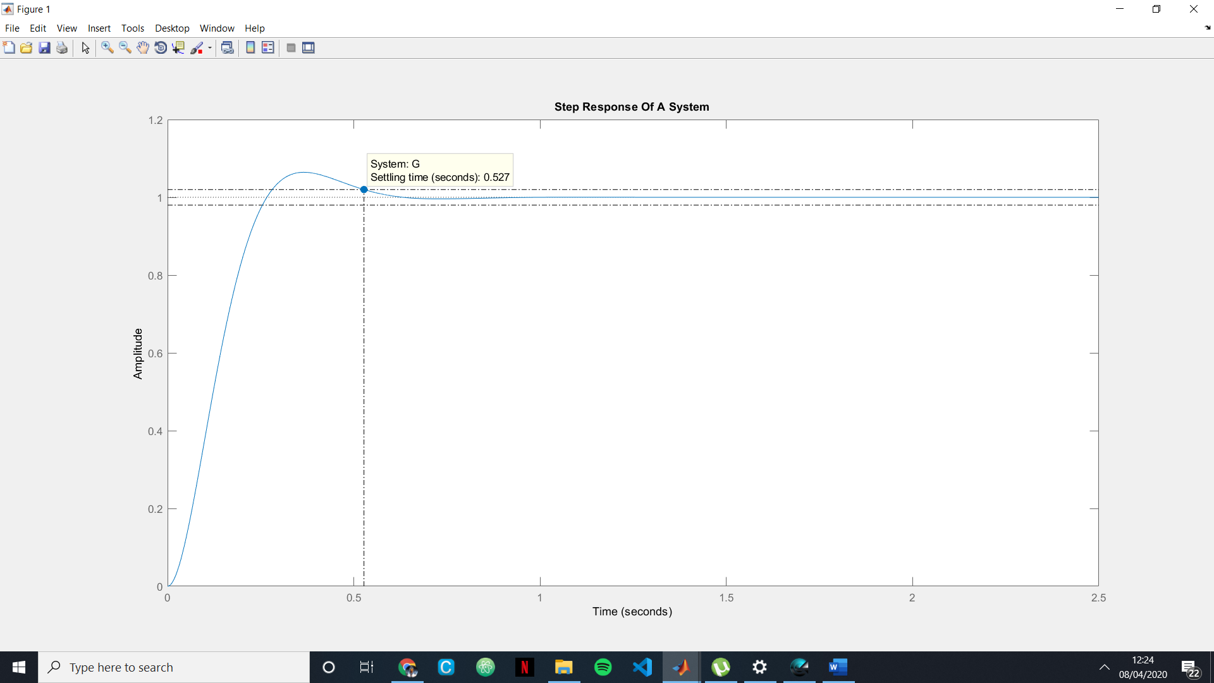

# Rise Time (tr):

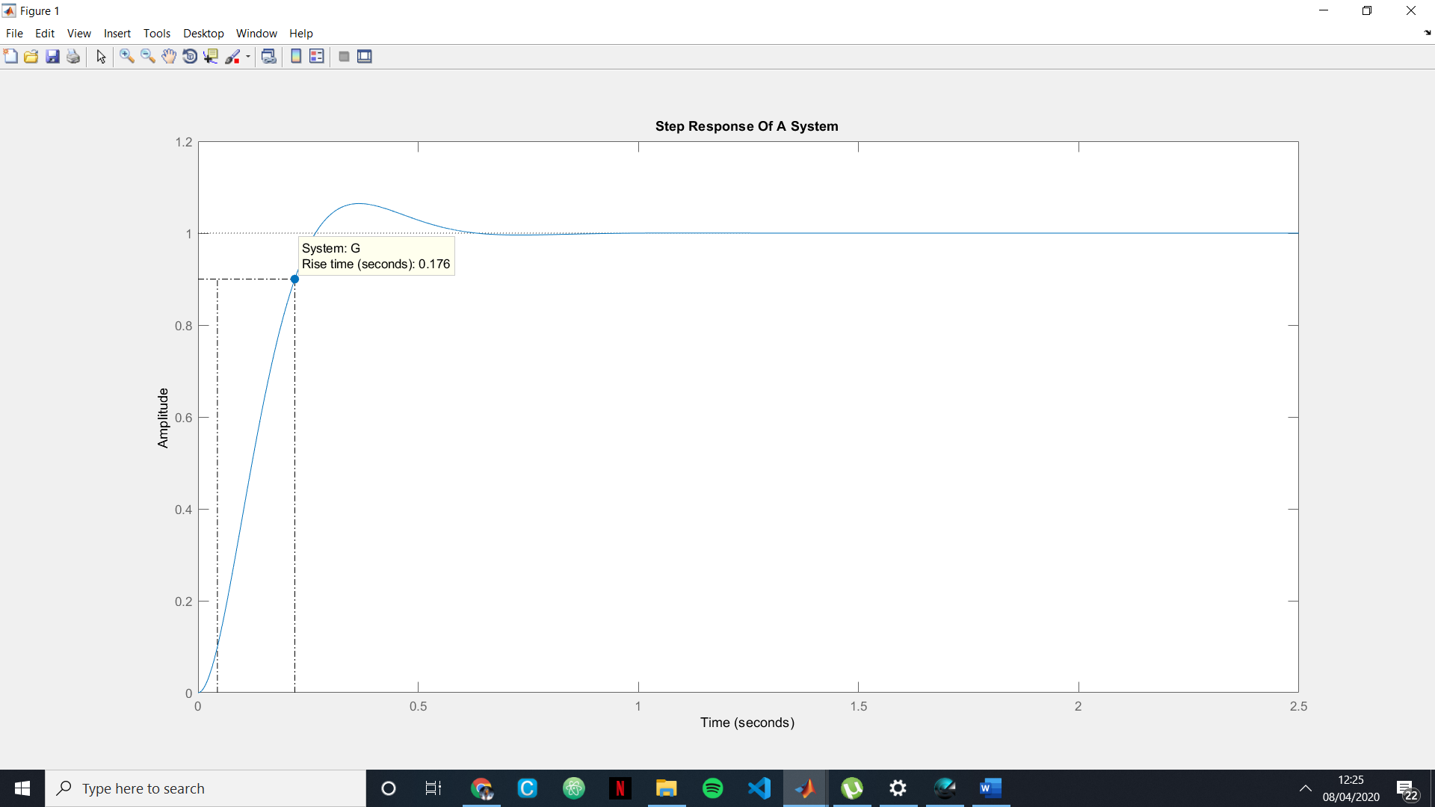

# Percentage Overshoot : Mp= 6%;

Ans (ii)::

0.045

G = -------------------------

s^2 + 0.025s + 0.045

Continuous-time transfer function.

# Peak Time (Tp):

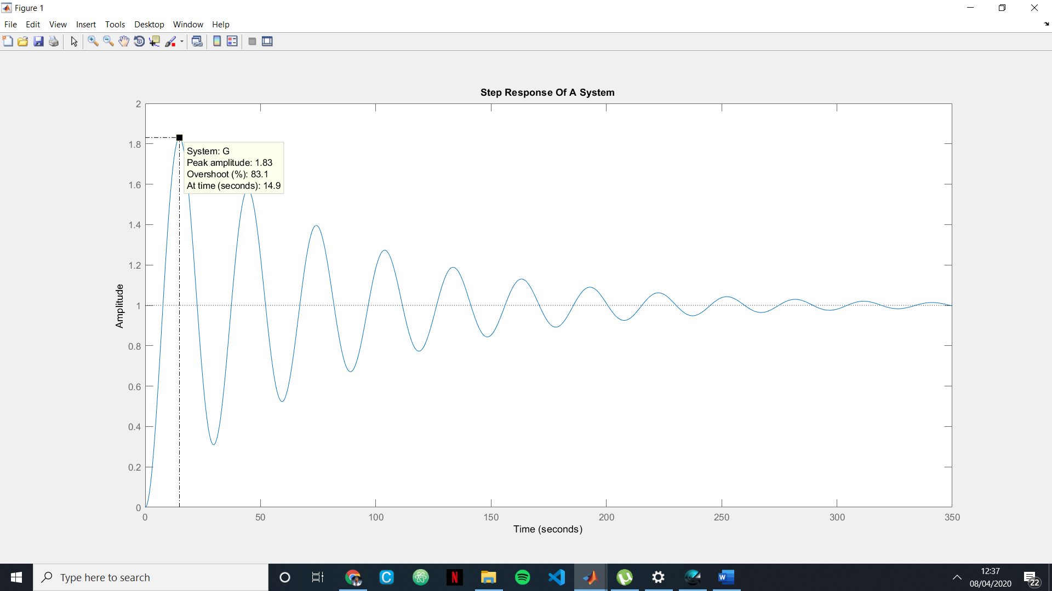

# Settling Time (ts):

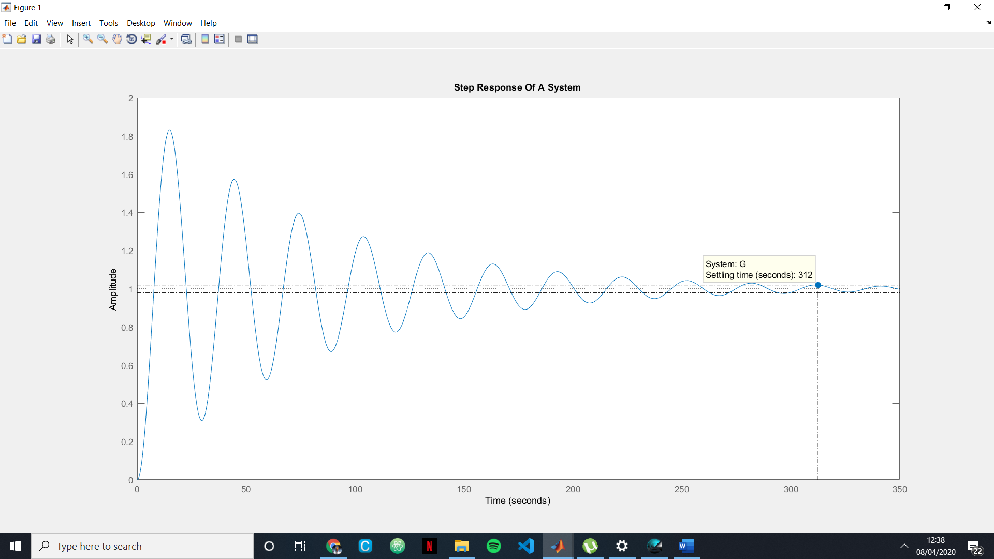

# Rise Time (tr):

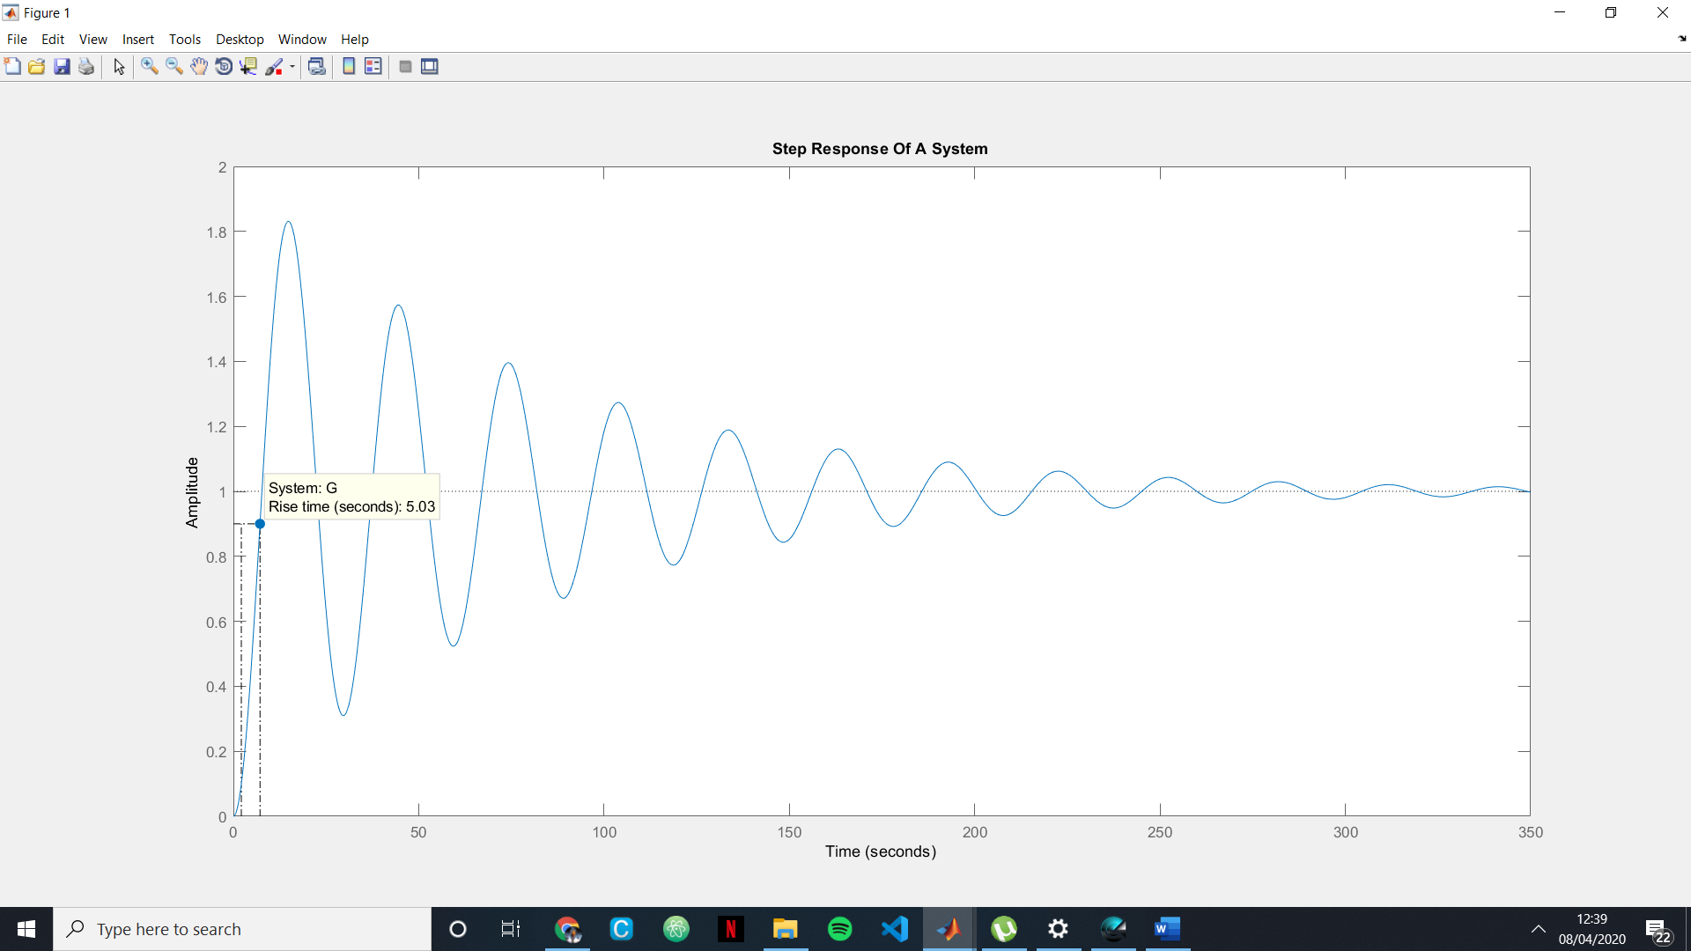

# Percentage Overshoot : Mp= 83%;

Ans (iii):

108

G = -------------------

s^2 + 1.325*103 s + 108

Continuous-time transfer function.

# Peak Time (Tp):

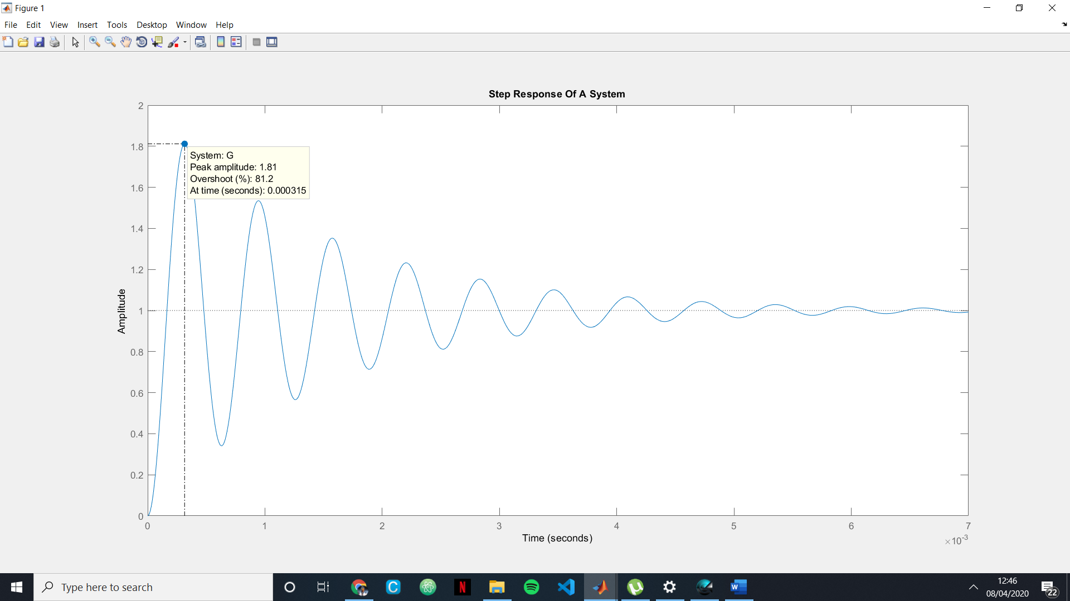

# Settling Time (ts):

# 

# Rise Time (tr):

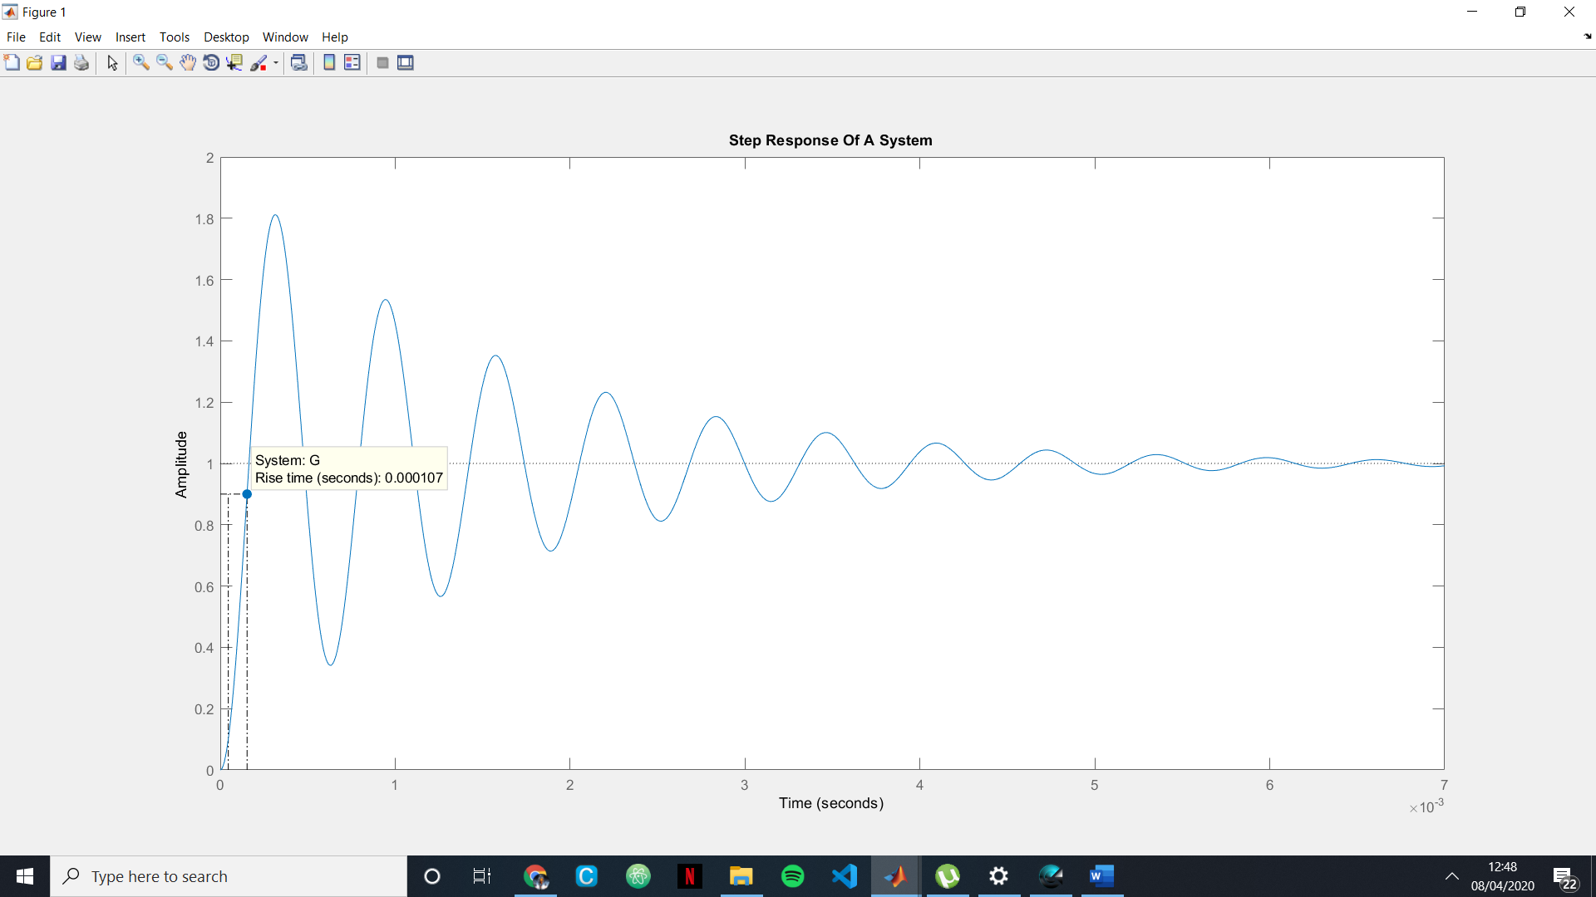

Percentage Overshoot :Mp=  81.2%;